**Weather Monitoring System**

Tracking and analyzing weather conditions in real-time. The "Weather Monitoring System" is a project that brings the power of Internet of Things (IoT) technology to environmental data monitoring. This system is designed to offer real-time insights into crucial atmospheric parameters like temperature, humidity, and overall environmental conditions, all accessible through the user-friendly Blynk app interface. By integrating a suite of sensors and IoT technology, we enable users to directly deploy the system in the field, obtaining live data feeds on their preferred devices, including smartphones and tablets. The data generated by these sensors can be effortlessly shared and viewed remotely via Blynk, making environmental data accessible anytime, anywhere. With Blynk's intuitive platform, users can effectively analyze and visualize this data, facilitating informed decision making and promoting environmental awareness. This project is poised to revolutionize atmospheric monitoring, placing valuable insights at the fingertips of farmers, weather forecasters, and environmental researchers, all through the convenience of the Blynk app interface

**Components**

* **MQ135 Sensor:** Gas sensor for detecting air quality. The MQ135 is a gas sensor that is sensitive to a variety of gases, including carbon dioxide, methane, and other pollutants. It is commonly used for air quality monitoring and can detect changes in the concentration of different gases.  
    
  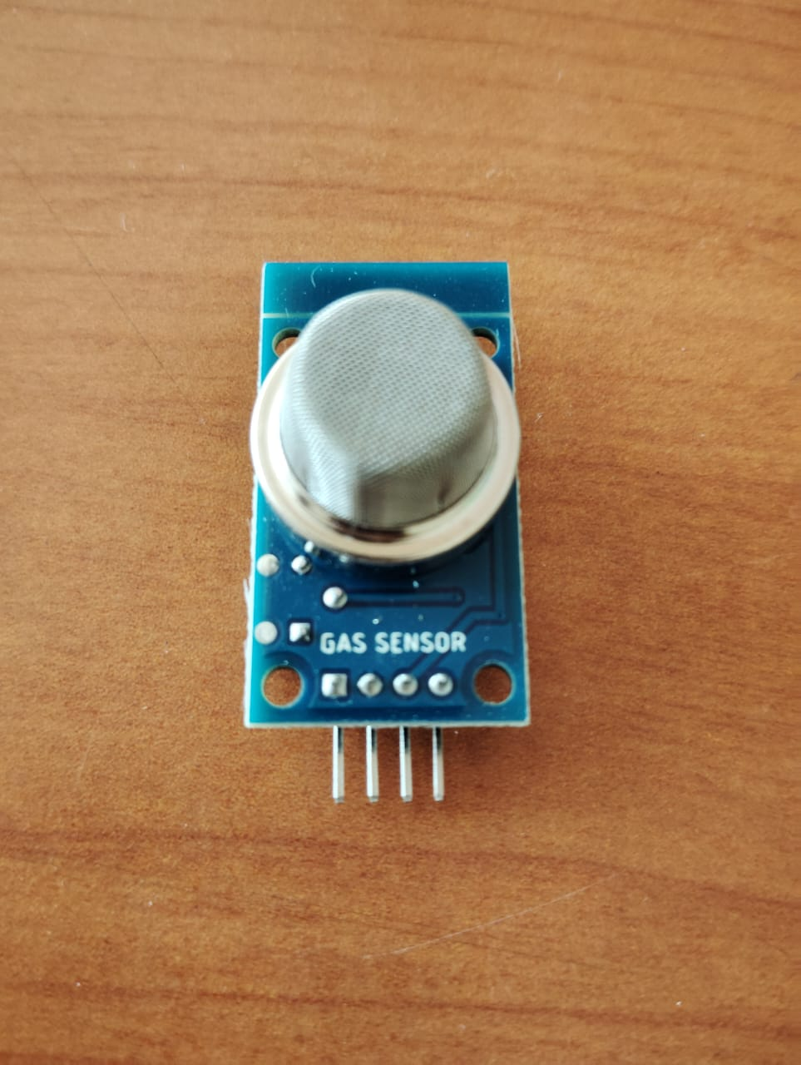
* **DHT11 Sensor:** Temperature and humidity sensor. It provides accurate and reliable measurements of ambient temperature and humidity, making it suitable for applications where climate data is crucial.  
    
  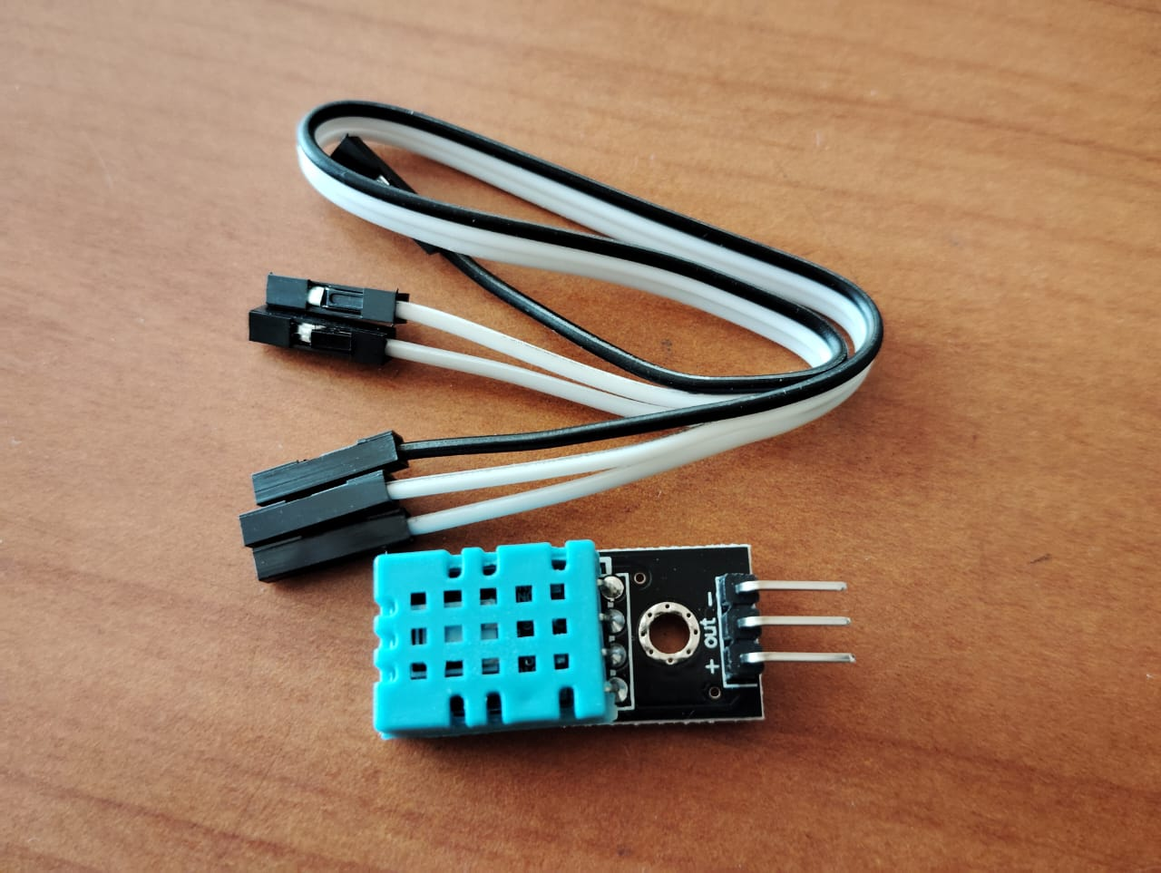
* **ESP32:** Microcontroller for processing and transmitting sensor data.The ESP32 is a powerful microcontroller with built-in Wi-Fi and Bluetooth capabilities. It is commonly used in IoT (Internet of Things) projects for collecting, processing, and transmitting sensor data to a central server.  
    
  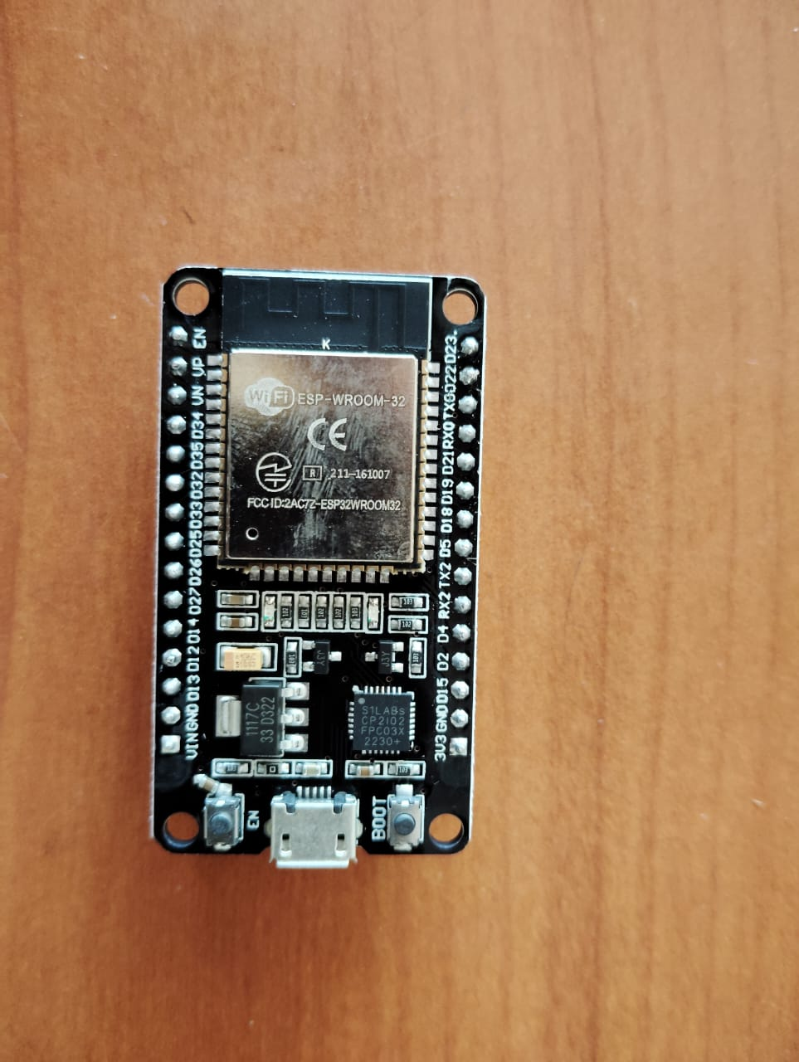
* **LCD Display:** Display module for visualizing weather data. The LCD (Liquid Crystal Display) module is used for visualizing real-time weather data. It provides a user-friendly interface to display temperature, humidity, and other relevant information collected by the sensors.  
    
  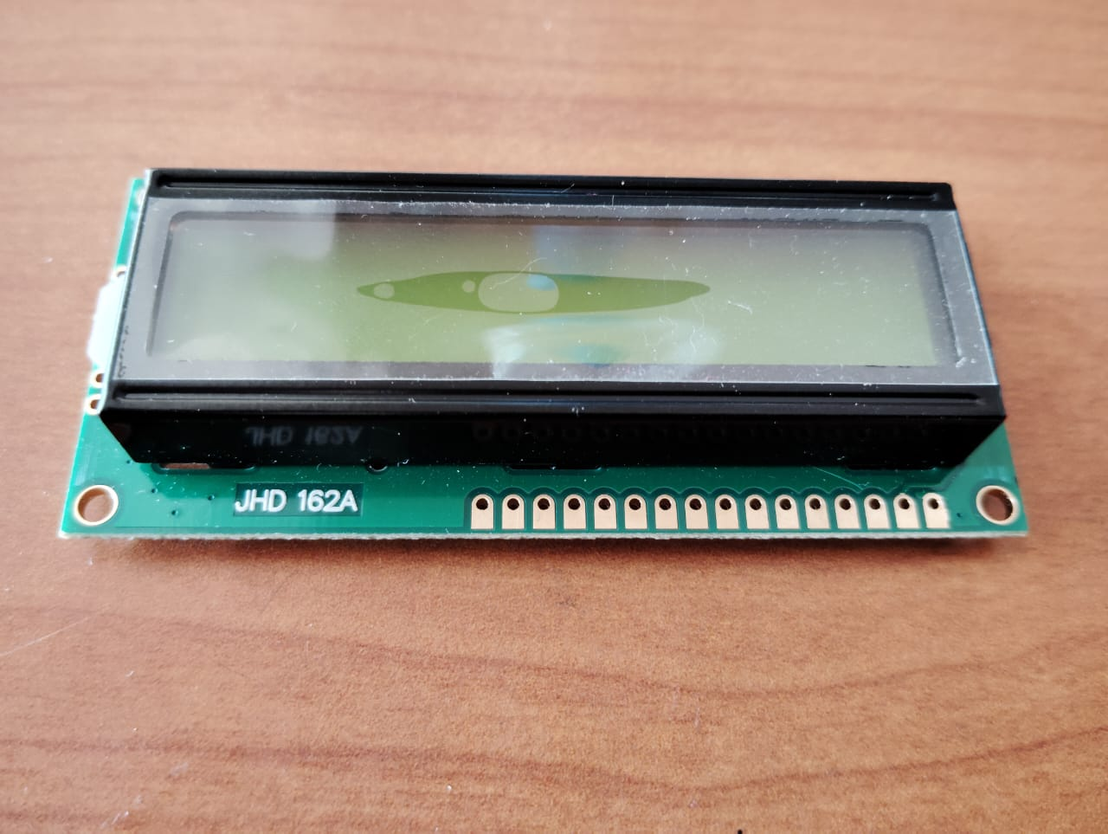
* **Jumper wire:**Jumper wires are essential components in electronics and prototyping. They are flexible wires with connectors at each end, typically used to establish connections between different points on a breadboard or between various components in a circuit.  
    
  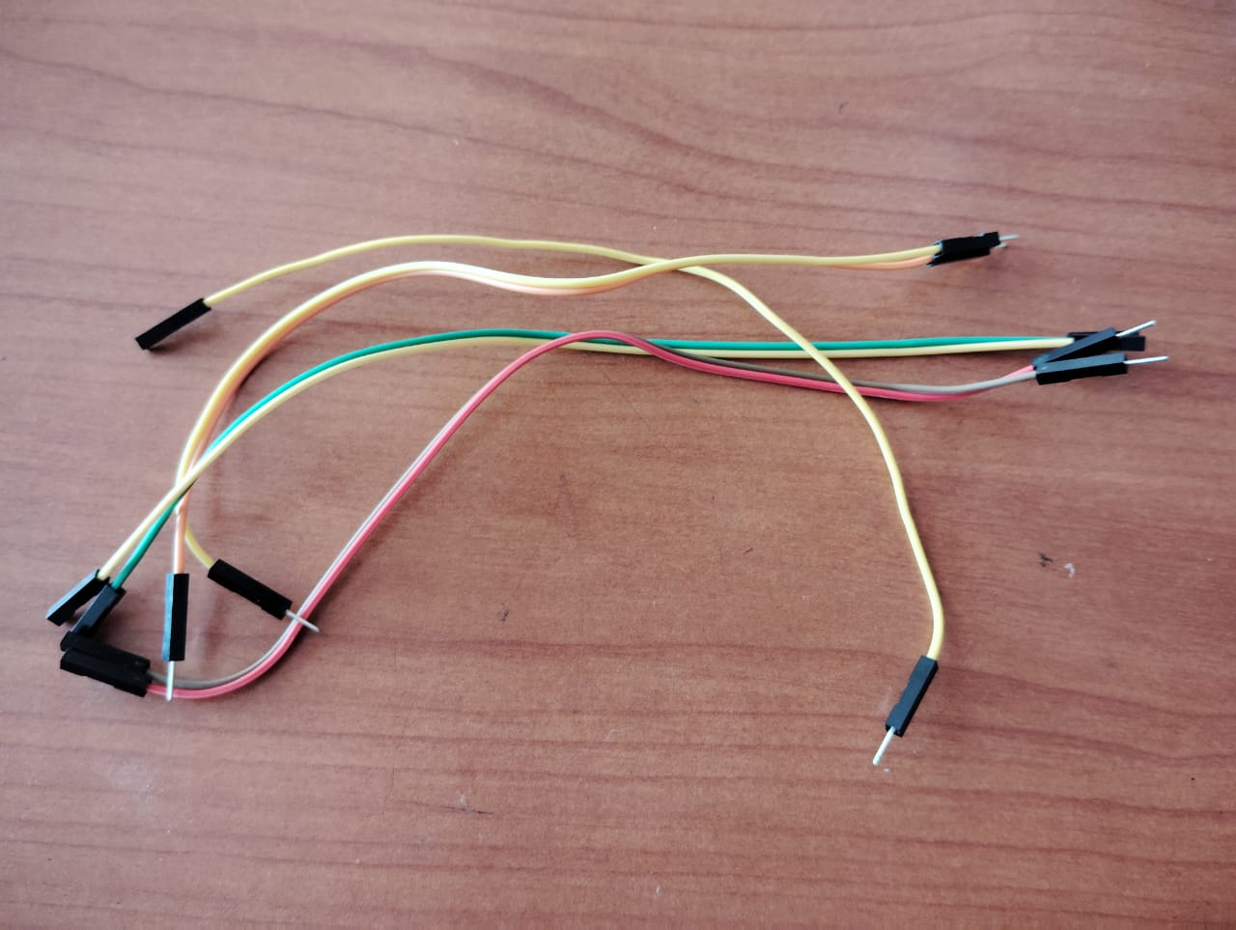
* **I2C Converter:** Interface converter for I2C communication.The I2C (Inter-Integrated Circuit) converter is an interface module that enables communication between devices using the I2C protocol. It facilitates the connection of multiple devices, such as sensors and displays, to a microcontroller with a single communication bus.  
    
  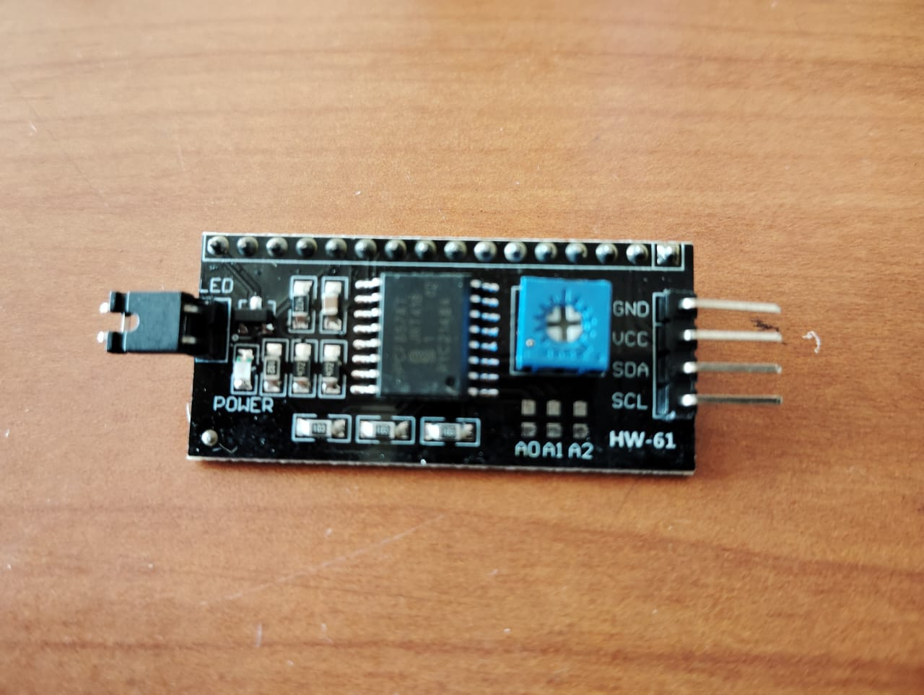

**Connection**

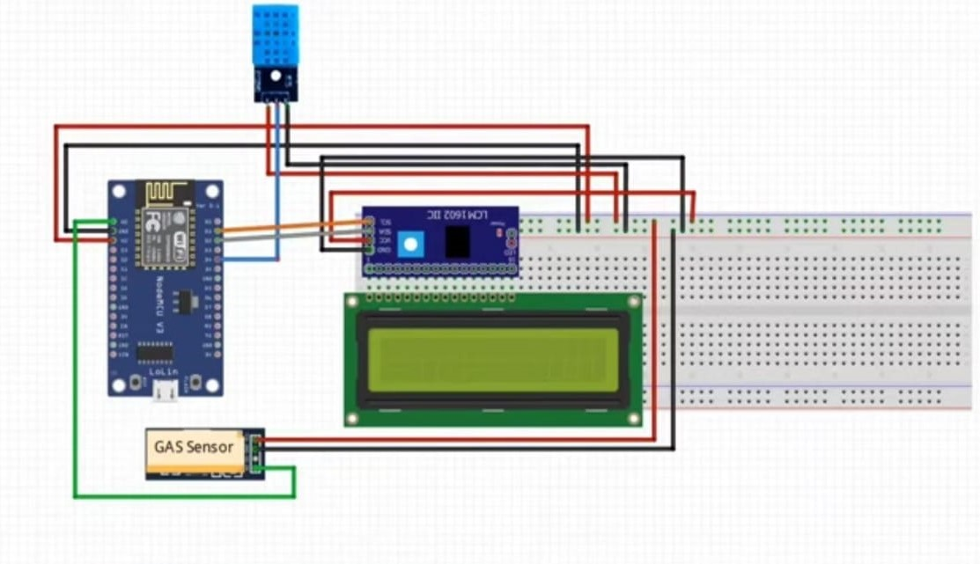

**Flowchart**

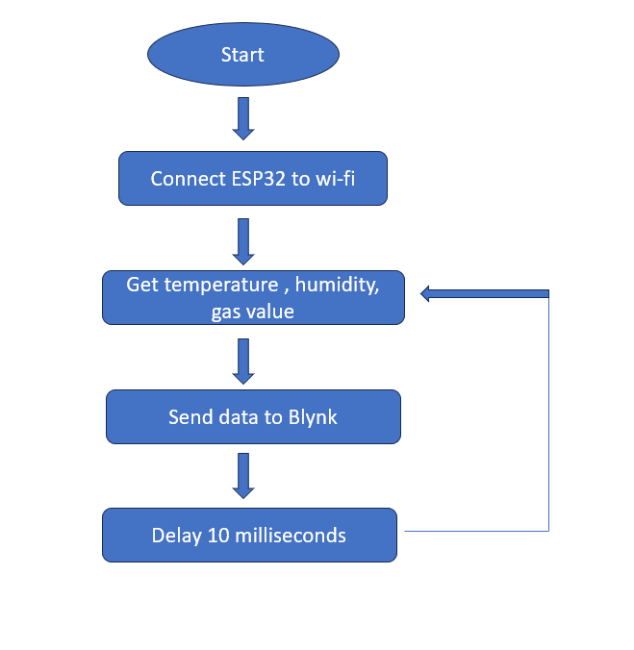

**Implementation**

1. Blynk Configuration:

-The Blynk template ID, device name, and authentication token are defined for Blynk integration.

-The 'BLYNK_PRINT' is set to 'Serial' for debugging purposes.

2. Libraries and Objects:

- The necessary libraries for WiFi, Blynk, DHT sensor, Wire, and LiquidCrystal_I2C are included.

- A 'LiquidCrystal_I2' object 'lcd' is created to control the LCD display.

- A custom character (degree symbol) is defined for later use.

3. WiFi and Blynk Initialization:

- WiFi credentials ('ssid' and 'pass') are provided.

- Blynk is initialized with the authentication token, WiFi credentials, and the Blynk timer is set up to

call the 'sendSensor' function every 30 seconds.

4. Sensor Reading and Blynk Updates:

- The 'sendSensor' function reads temperature, humidity, and gas values.

- If the DHT sensor readings are valid (not NaN), the values are sent to Blynk virtual pins (`V0`, `V1`, and

`V2`) for display in the Blynk app.

5. LCD Display Setup:

- The LCD is initialized and displays an introductory message for 2 seconds before clearing the screen.

6. Main Loop:

- The 'loop' function runs continuously.

- Blynk is serviced ('Blynk.run()') and the Blynk timer is checked ('timer.run()').

- The temperature, humidity, and gas values are read again for local display on the LCD.

- Depending on the gas value, different messages are displayed on the LCD indicating whether the air quality

is "Fresh Air" or "Bad Air."

- If the gas value is above 600, a Blynk event log is created to indicate "Bad Air."

7. LCD Display of Sensor Values:

- The LCD displays temperature, humidity, and gas values in different sections on the screen with

appropriate units.

- Custom characters are used for better visual representation.

This is designed for an ESP32 microcontroller with sensors for temperature, humidity (DHT sensor), and

gas, along with an LCD display for local monitoring. The Blynk integration allows remote monitoring and

alerting. The gas value is used to determine air quality, and actions (such as logging an event) are taken

based on the threshold value of 600. The LCD provides a local interface for quick feedback on the air

quality.

**Result**

* **Temperature**  
  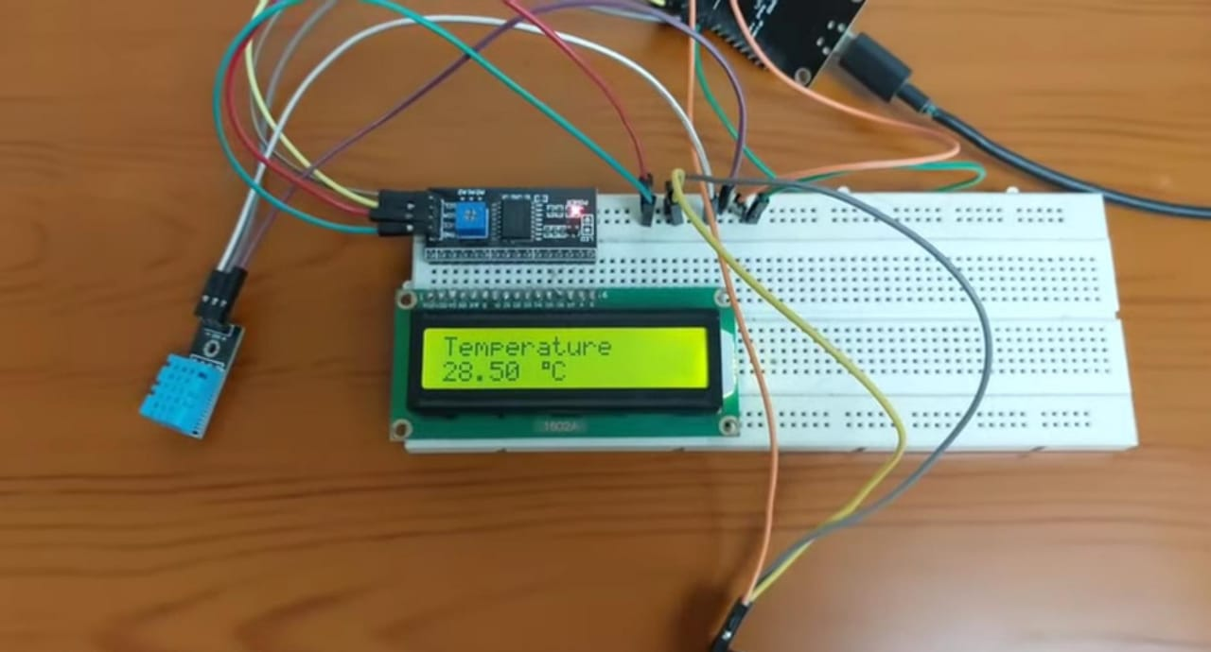
* **Humidity**  
  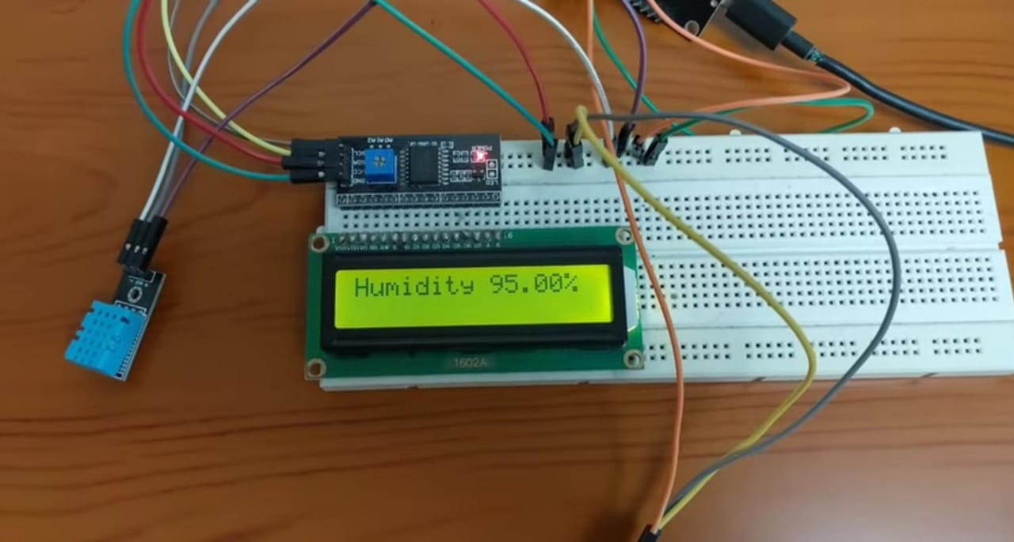
* **Gas value**  
  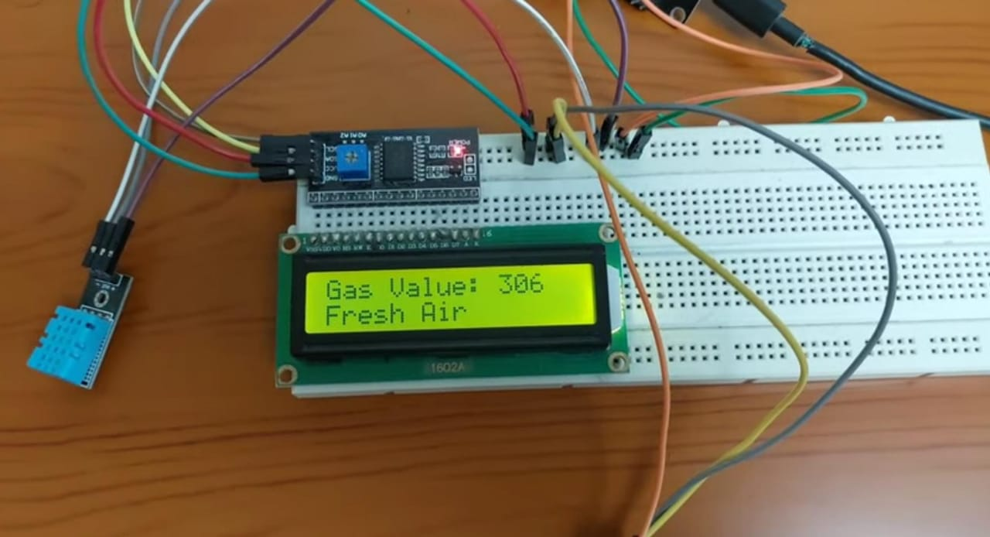
* **Output**  
  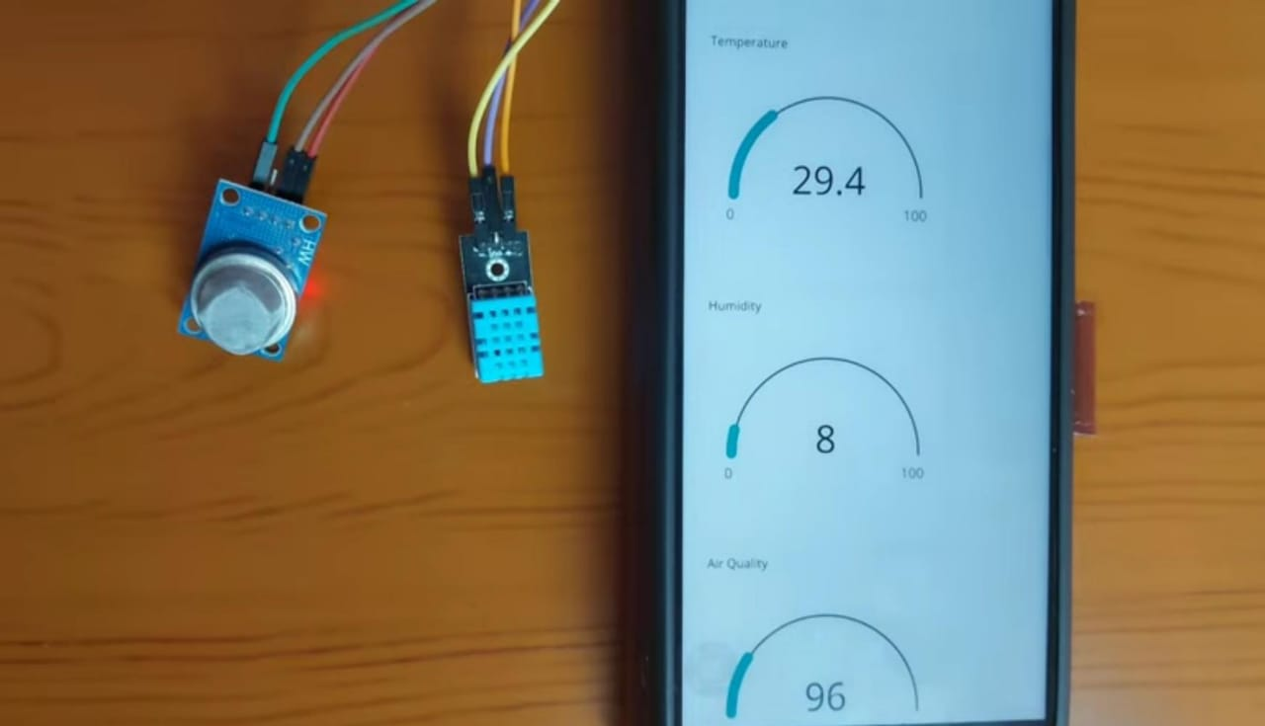

©Weather Monitoring System. All rights reserved.